DIRECTIONS TO KNOWLE HOUSE
4 Norfolk Park Road, Sheffield S2 3QE [NB: the main entrance to our drive is directly under the tram bridge near the junction with East Bank Road]
Note that satellite navigation systems don’t find Knowle House from the postcode alone. Google Maps may send you to the top end of Norfolk Park Road.
Vida Sheffield Tel: [0114] 275 0101

Please note: the new entrance to Knowle House is just a short distance up Norfolk Park Road under the tram bridge [map below looks like junction with Park Grange Rd.]

Drivers: turn off Queens Road up Duchess Road, which passes between the Casino and B&Q. This starts to bear right onto East Bank Road, then turn first left into the bottom of Norfolk Park Road. Just under the tramway bridge, turn right into a short drive leading to the car park and building.
Parking: there is usually parking in the main car park.
Disabled Parking: there is limited space for parking close to the main building at the top of the drive – you reach the drive via the main gates, by crossing through the car park. Please ring the number above if you need any assistance.

Buses: the number 41 bus runs from Sheffield Interchange or Arundel Gate, to the stop on Queens Road near the Casino [Duchess Rd]. The 24 or 25 also stops on Queens Road but only when travelling towards town. Then please follow the directions for drivers.

Tram: take the Herdings/Halfway line – the Park Grange Croft tram stop is marked on the map. Travelling from town, or the railway station, it’s the stop after Sheffield College.
On leaving the tram, you could enter the top gates for Knowle House by the tram stop, but first check how to gain entry from the rear of the building by ringing the office. If no-one is available, it is best to walk a little way downhill from the tram stop until you see the entry to Knowle House car park on your left – just under the tram bridge.

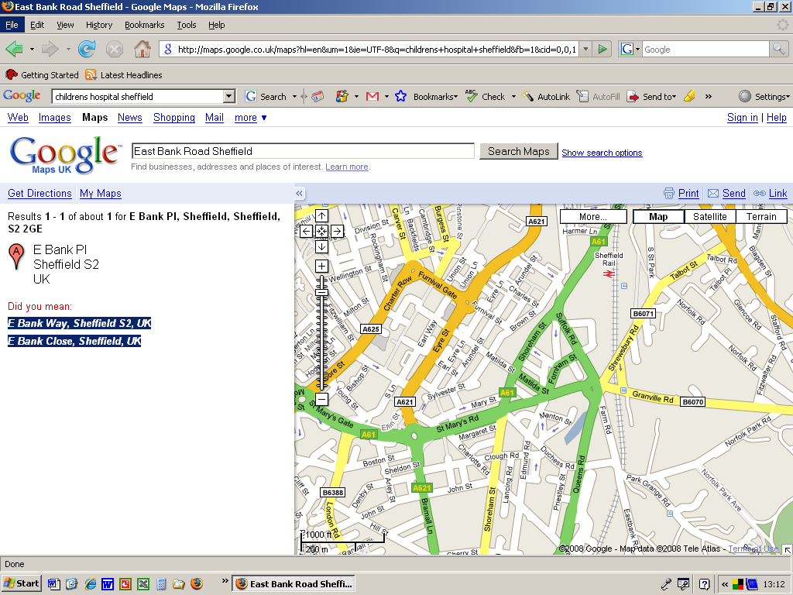
Park Grange Croft
Tram Stop on
Herdings and Halfway Lines

Knowle House 

